##### <Admin> Ban

**Use Case Diagram**

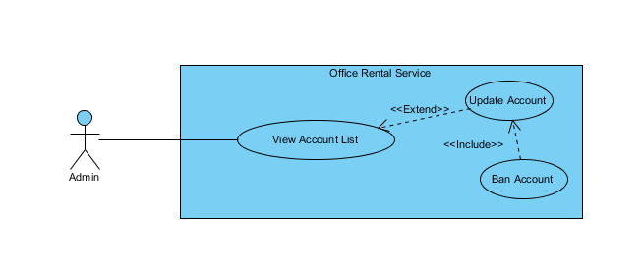

**Figure 1: <Admin> Ban account use case**

**Use Case Specification**

|  |  |  |  |  |
| --- | --- | --- | --- | --- |
| **USE CASE – BAN** | | | | |
| **Use-case No.** |  | **Use-case Version** | | 2.0 |
| **Use-case Name** | Request repair | | | |
| **Author** | Trần Lê Tuấn | | | |
| **Date** | 25/05/2015 | **Priority** | Normal | |
| **Actor:**   * Admin   **Summary:**   * This use case allows admin to ban an account.   **Goal:**   * Admin can ban an account successful.   **Triggers:**   * Click “Người dùng” in menu. * Click “Sửa” icon in menu. * Click “Khoá tài khoản” button.   **Preconditions:**   * User must login in system.   **Post Conditions:**   * **Success**: account has been banned successfully. * **Fail:** Cannot ban account.   **Main Success Scenario:**   |  |  |  | | --- | --- | --- | | Step | Actor Action | System Response | | 1 | Click “Sửa” icon on submenu. | Show page account detail  Display account details includes:   * Tên tài khoản: Label * Mật khẩu: Password * Email: Textbox * Chức vụ: Dropdown list   “Huỷ” : button  “Cập nhật” : button  “Khoá tài khoản” : button | | 2 | Click “Khoá tài khoản” button on screen.  [Alternative 1] | Show successful message “Khoá tài khoản thành công.” on screen.  [Exception 1] | |  |  |  |   **Alternative Scenario:**   |  |  |  | | --- | --- | --- | | No. | Actor Action | System Response | | 1 | Click “Huỷ” button. | Close page and go to account management page. |   **Exceptions:**   |  |  |  | | --- | --- | --- | | No. | Actor Action | System Response | | 1 | Cannot send request due to database connection | Show error message: “Không thể gửi yêu cầu, vui lòng thử lại sau.” |   **Relationships:** Role Account  **Business Rules:**   * The role of banned account is “Customer/Manager/Staff” and status is “Active”. * Account information must exist in system. | | | | |

##### <Admin> Create account

**Use Case Diagram**

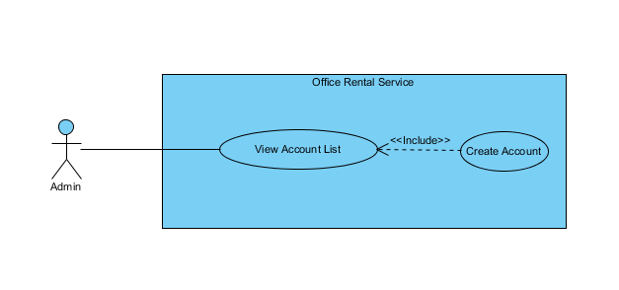

**Figure 2: <Admin> Create account use case diagram**

**Use Case Specification**

|  |  |  |  |  |
| --- | --- | --- | --- | --- |
| **USE CASE – CREATE ACCOUNT** | | | | |
| **Use-case No.** |  | **Use-case Version** | | 2.0 |
| **Use-case Name** | Create Account | | | |
| **Author** | Trần Lê Tuấn | | | |
| **Date** | 25/05/2015 | **Priority** | Normal | |
| **Actor:**   * Admin   **Summary:**   * This use case allows admin to create account.   **Goal:**   * Admin can create account successful.   **Triggers:**   * Click “Người dùng” in menu. * Click “Thêm mới tài khoản” in menu.   **Preconditions:**   * User must login in system.   **Post Conditions:**   * **Success**: create account successfully. * **Fail:** Cannot create account   **Main Success Scenario:**   |  |  |  | | --- | --- | --- | | Step | Actor Action | System Response | | 1 | Click “Người dùng” on menu. | Show page account management  Display account details includes:   * Thêm mới tài khoản: Link * Tên đăng nhập: Label * Email: Password * Chức vụ: Dropdown list * Tình trạng: Label * Tác vụ:   + “Xoá”: Button  +”Sửa”: Button | | 2 | Click “Thêm mới tài khoản” on menu. | Show page account management  Display account details includes:   * Tên tài khoản: Label * Mật khẩu: Password * Email: Textbox * Chức vụ: Dropdown list   “Huỷ” : Button  “Tạo mới” : Button | | 3 | Click “Tạo mới” button on screen.  [Alternative 1] | Show successful message “Tạo tài khoản thành công.” on screen.  [Exception 1] | |  |  |  |   **Alternative Scenario:**   |  |  |  | | --- | --- | --- | | No. | Actor Action | System Response | | 1 | Click “Huỷ” button. | Close page and go to account management page. |   **Exceptions:**   |  |  |  | | --- | --- | --- | | No. | Actor Action | System Response | | 1 | Cannot send request due to database connection | Show error message: “Không thể gửi yêu cầu, vui lòng thử lại sau.” |   **Relationships:** Role Account  **Business Rules:**   * Username must be different from existed username in system. * The role of new created account is “Admin/Manager/Staff/Customer” and status is “Active”. | | | | |

##### < Admin> Delete account

**Use Case Diagram**

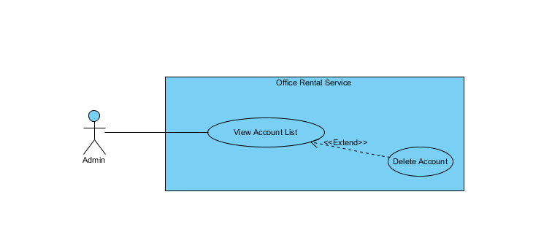

**Figure 3: <Admin> Delete use case diagram**

**Use Case Specification**

|  |  |  |  |  |
| --- | --- | --- | --- | --- |
| **USE CASE – DELETE USER** | | | | |
| **Use-case No.** |  | **Use-case Version** | | 2.0 |
| **Use-case Name** | Delete account | | | |
| **Author** | Trần Lê Tuấn | | | |
| **Date** | 25/05/2015 | **Priority** | Normal | |
| **Actor:**   * Admin   **Summary:**   * This use case allows admin to delete account.   **Goal:**   * Admin can delete account successful.   **Triggers:**   * Click “Người dùng” in menu. * Click “Xoá tài khoản” in menu.   **Preconditions:**   * User must login in system.   **Post Conditions:**   * **Success**: delete account successfully. * **Fail:** Cannot delete account   **Main Success Scenario:**   |  |  |  | | --- | --- | --- | | Step | Actor Action | System Response | | 1 | Click “Người dùng” on menu. | Show page account management  Display account details includes:   * Tên đăng nhập: Label * Email: Label * Chức vụ: Label * Tình trạng: Label * Tác vụ: Label   “Xoá” : Button  “Sửa” : Button | | 2 | Click “Xoá” button on screen. | Show successful message “Xoá tài khoản thành công.” on screen.  [Exception 1] | |  |  |  |   **Alternative Scenario:**   |  |  |  | | --- | --- | --- | | No. | Actor Action | System Response | |  |  |  |   **Exceptions:**   |  |  |  | | --- | --- | --- | | No. | Actor Action | System Response | | 1 | Cannot send request due to database connection | Show error message: “Không thể gửi yêu cầu, vui lòng thử lại sau.” |   **Relationships:** Role Account  **Business Rules:**   * Account information must exist in database system. * The role of delete account is “Manager/Staff/Customer” and status is “Normal”. | | | | |

##### < Admin> Update account

**Use Case Diagram**

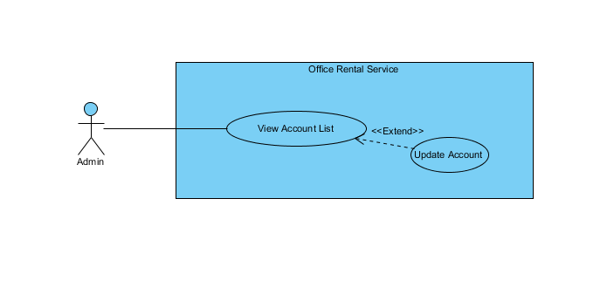

**Figure 4: <Admin> Update account use case diagram**

**Use Case Specification**

|  |  |  |  |  |
| --- | --- | --- | --- | --- |
| **USE CASE – UPDATE ACCOUNT** | | | | |
| **Use-case No.** |  | **Use-case Version** | | 2.0 |
| **Use-case Name** | Update Account | | | |
| **Author** | Trần Lê Tuấn | | | |
| **Date** | 25/05/2015 | **Priority** | Normal | |
| **Actor:**   * Admin   **Summary:**   * This use case allows admin to edit account.   **Goal:**   * Admin can edit account successful.   **Triggers:**   * Click “Người dùng” in menu. * Click “Sửa” in menu.   **Preconditions:**   * User must login in system.   **Post Conditions:**   * **Success**: create account successfully. * **Fail:** Cannot create account   **Main Success Scenario:**   |  |  |  | | --- | --- | --- | | Step | Actor Action | System Response | | 1 | Click “Người dùng” on menu. | Show page account management  Display account details includes:   * Tên đăng nhập: Label * Email: Label * Chức vụ: Label * Tình trạng: Label * Tác vụ: Label   “Xoá” : Button  “Sửa” : Button | | 2 | Click “Sửa” on menu. | Show page account management  Display account details includes:   * Tên tài khoản: Label * Mật khẩu: Password * Email: Textbox * Chức vụ: Dropdown list   “Huỷ” : Button  “Tạo mới” : Button | | 3 | Click “Cập nhật” button on screen.  [Alternative 1] | Show successful message “Cập nhật tài khoản thành công.” on screen.  [Exception 1] | |  |  |  |   **Alternative Scenario:**   |  |  |  | | --- | --- | --- | | No. | Actor Action | System Response | | 1 | Click “Huỷ” button. | Close page and go to account management page. |   **Exceptions:**   |  |  |  | | --- | --- | --- | | No. | Actor Action | System Response | | 1 | Cannot send request due to database connection | Show error message: “Không thể gửi yêu cầu, vui lòng thử lại sau.” |   **Relationships:** Role Account  **Business Rules:**   * Account information must exist in database system. * Cannot change username. * Account has been delete can not edit. | | | | |

##### < Admin> Unban account

**Use Case Diagram**

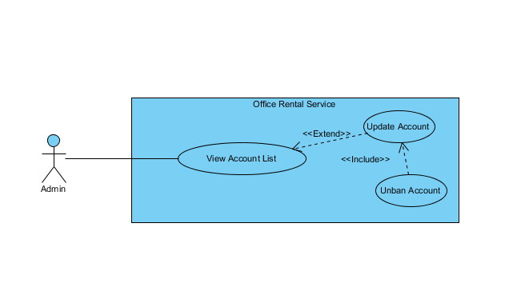

**Figure 5: <Admin> Unban account use case diagram**

**Use Case Specification**

|  |  |  |  |  |
| --- | --- | --- | --- | --- |
| **USE CASE – UNBAN ACCOUNT** | | | | |
| **Use-case No.** |  | **Use-case Version** | | 2.0 |
| **Use-case Name** | Unban Account | | | |
| **Author** | Trần Lê Tuấn | | | |
| **Date** | 25/05/2015 | **Priority** | Normal | |
| **Actor:**   * Admin   **Summary:**   * This use case allows admin to unban an account.   **Goal:**   * Admin can unban an account successful.   **Triggers:**   * Click “Người dùng” in menu. * Click “Sửa” icon in menu. * Click “Mở tài khoản” button.   **Preconditions:**   * User must login in system.   **Post Conditions:**   * **Success**: account has been banned successfully. * **Fail:** Cannot ban account.   **Main Success Scenario:**   |  |  |  | | --- | --- | --- | | Step | Actor Action | System Response | | 1 | Click “Người dùng” on menu. | Show page account management  Display account details includes:   * Tên đăng nhập: Label * Email: Label * Chức vụ: Label * Tình trạng: Label * Tác vụ: Label   “Xoá” : Button  “Sửa” : Button | | 2 | Click “Sửa” icon on submenu. | Show page account detail  Display account details includes:   * Tên tài khoản: Label * Mật khẩu: Password * Email: Textbox * Chức vụ: Dropdown list   “Huỷ” : button  “Cập nhật” : button  “Mở tài khoản” : button | | 3 | Click “Mở tài khoản” button on screen.  [Alternative 1] | Show successful message “Mở tài khoản thành công.” on screen.  [Exception 1] | |  |  |  |   **Alternative Scenario:**   |  |  |  | | --- | --- | --- | | No. | Actor Action | System Response | | 1 | Click “Huỷ” button. | Close page and go to account management page. |   **Exceptions:**   |  |  |  | | --- | --- | --- | | No. | Actor Action | System Response | | 1 | Cannot send request due to database connection | Show error message: “Không thể gửi yêu cầu, vui lòng thử lại sau.” |   **Relationships:** Role Account  **Business Rules:**   * The role of banned account is “Customer/Manager/Staff” and status is “Active”. * Account information must exist in system. | | | | |

##### < Manager> Cancel extend request

**Use Case Diagram**

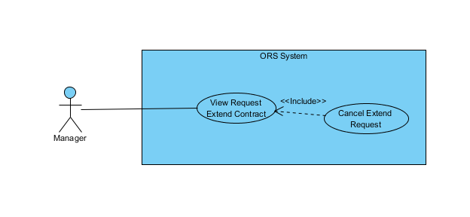

**Figure 6: <Manager> Cancel extend request use case diagram**

**Use Case Specification**

|  |  |  |  |  |
| --- | --- | --- | --- | --- |
| **USE CASE – CANCEL EXTEND REQUEST** | | | | |
| **Use-case No.** |  | **Use-case Version** | | 2.0 |
| **Use-case Name** | Cancel Extend Request | | | |
| **Author** | Trần Lê Tuấn | | | |
| **Date** | 25/05/2015 | **Priority** | Normal | |
| **Actor:**   * Manager   **Summary:**   * This use case allows manager to cancel request.   **Goal:**   * Manager can cancel request successful.   **Triggers:**   * Click “Yêu cầu của khách hàng” in menu. * Click “Xem chi tiết” icon in menu. * Click “Huỷ yêu cầu” button.   **Preconditions:**   * User must login in system.   **Post Conditions:**   * **Success**: contract has been canceled successfully. * **Fail:** Cannot cancel request.   **Main Success Scenario:**   |  |  |  | | --- | --- | --- | | Step | Actor Action | System Response | | 1 | Click “Yêu cầu khách hàng” on menu. |  | | 2 | Click “Gia hạn” on submenu. | Show page request detail  Display request details includes:   * Khách hàng: Label * Văn phòng: Label * Ngày bắt đầu: Label * Ngày kết thúc: Label * Giá: Label * Thời hạn thanh toán: Label * Xem chi tiết: Link | | 3 | Click “Xem chi tiết” link on screen. | Display request details includes:   * Khách hàng: Label * Văn phòng: Label * Ngày kết thúc: Textbox * Thời hạn thanh toán: Dropdown list * Giá: Textbox   “Xác nhận” : button  “Huỷ yêu cầu” : button  “Quay về” : button | | 4 | Click “Huỷ yêu cầu” button on screen.  [Alternative 1] | Show successful message “Huỷ yêu cầu thành công.” on screen.  [Exception 1] |   **Alternative Scenario:**   |  |  |  | | --- | --- | --- | | No. | Actor Action | System Response | | 1 | Click “Quay về” button. | Close request page and go to management page. |   **Exceptions:**   |  |  |  | | --- | --- | --- | | No. | Actor Action | System Response | | 1 | Cannot send request due to database connection | Show error message: “Không thể gửi yêu cầu, vui lòng thử lại sau.” |   **Relationships:** Contract  **Business Rules:**   * Cancel extend request must exist in database system. * Extend contract will not update after cancel extend request. * Contract that extend request for must exist in database. | | | | |

##### < Manager> Cancel return request

**Use Case Diagram**

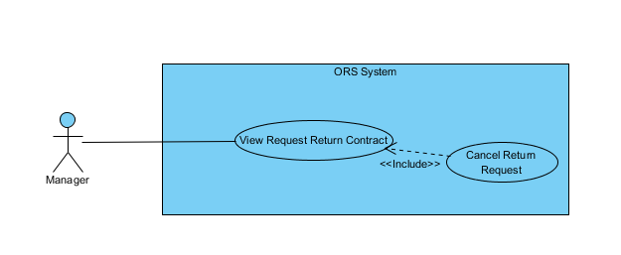

**Figure 7: <Manager> Cancel return request use case diagram**

**Use Case Specification**

|  |  |  |  |  |
| --- | --- | --- | --- | --- |
| **USE CASE – CANCEL RETURN REQUEST** | | | | |
| **Use-case No.** |  | **Use-case Version** | | 2.0 |
| **Use-case Name** | Cancel Return Request | | | |
| **Author** | Trần Lê Tuấn | | | |
| **Date** | 25/05/2015 | **Priority** | Normal | |
| **Actor:**   * Manager   **Summary:**   * This use case allows manager to cancel request.   **Goal:**   * Manager can cancel request successful.   **Triggers:**   * Click “Yêu cầu của khách hàng” in menu. * Click “Xem chi tiết” icon in menu. * Click “Huỷ yêu cầu” button.   **Preconditions:**   * User must login in system.   **Post Conditions:**   * **Success**: contract has been canceled successfully. * **Fail:** Cannot cancel request.   **Main Success Scenario:**   |  |  |  | | --- | --- | --- | | Step | Actor Action | System Response | | 1 | Click “Yêu cầu khách hàng” on menu. |  | | 2 | Click “Huỷ trước hạn” on submenu. | Show page request detail  Display request details includes:   * Khách hàng: Label * Văn phòng: Label * Ngày bắt đầu: Label * Ngày kết thúc: Label * Giá: Label * Thời hạn thanh toán: Label * Xem chi tiết: Link | | 3 | Click “Xem chi tiết” link on screen. | Display request details includes:   * Khách hàng: Label * Văn phòng: Label * Ngày kết thúc: Textbox * Thời hạn thanh toán: Dropdown list * Giá: Textbox   “Xác nhận” : button  “Huỷ yêu cầu” : button  “Quay về” : button | | 4 | Click “Huỷ yêu cầu” button on screen.  [Alternative 1] | Show successful message “Huỷ yêu cầu thành công.” on screen.  [Exception 1] |   **Alternative Scenario:**   |  |  |  | | --- | --- | --- | | No. | Actor Action | System Response | | 1 | Click “Quay về” button. | Close request page and go to management page. |   **Exceptions:**   |  |  |  | | --- | --- | --- | | No. | Actor Action | System Response | | 1 | Cannot send request due to database connection | Show error message: “Không thể gửi yêu cầu, vui lòng thử lại sau.” |   **Relationships:** Contract  **Business Rules:**   * Cancel return request must exist in database system. * Return contract will not update after cancel return request. * Contract that return request for must exist in database. | | | | |

##### < Manager> Accept return contract

**Use Case Diagram**

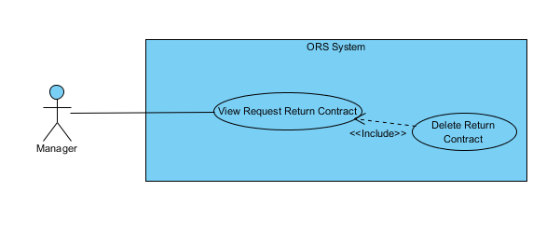

**Figure 8: <Manager> Accept return contract use case diagram**

**Use Case Specification**

|  |  |  |  |  |
| --- | --- | --- | --- | --- |
| **USE CASE –ACCEPT RETURN CONTRACT** | | | | |
| **Use-case No.** |  | **Use-case Version** | | 2.0 |
| **Use-case Name** | Accept Return Contract | | | |
| **Author** | Trần Lê Tuấn | | | |
| **Date** | 25/05/2015 | **Priority** | Normal | |
| **Actor:**   * Manager   **Summary:**   * This use case allows manager to delete contract.   **Goal:**   * Manager can delete contract successful.   **Triggers:**   * Click “Yêu cầu của khách hàng” in menu. * Click “Xem chi tiết” icon in menu. * Click “Xác nhận” button.   **Preconditions:**   * User must login in system.   **Post Conditions:**   * **Success**: contract has been deleted successfully. * **Fail:** Cannot delete contract.   **Main Success Scenario:**   |  |  |  | | --- | --- | --- | | Step | Actor Action | System Response | | 1 | Click “Yêu cầu khách hàng” on menu. |  | | 2 | Click “Huỷ trước hạn” on submenu. | Show page request detail  Display request details includes:   * Khách hàng: Label * Văn phòng: Label * Ngày bắt đầu: Label * Ngày kết thúc: Label * Giá: Label * Thời hạn thanh toán: Label * Xem chi tiết: Link | | 3 | Click “Xem chi tiết” link on screen. | Display request details includes:   * Khách hàng: Label * Văn phòng: Label * Ngày kết thúc: Textbox * Thời hạn thanh toán: Dropdown list * Giá: Textbox   “Xác nhận” : button  “Huỷ yêu cầu” : button  “Quay về” : button | | 4 | Click “Xác nhận” button on screen.  [Alternative 1] | Show successful message “xoá thành công.” on screen.  [Exception 1] |   **Alternative Scenario:**   |  |  |  | | --- | --- | --- | | No. | Actor Action | System Response | | 1 | Click “Quay về” button. | Close request page and go to management page. |   **Exceptions:**   |  |  |  | | --- | --- | --- | | No. | Actor Action | System Response | | 1 | Cannot send request due to database connection | Show error message: “Không thể gửi yêu cầu, vui lòng thử lại sau.” |   **Relationships:** Contract  **Business Rules:**   * Accept return request must exist in database system. * Return contract will update after accept return request. * Contract that accept return request for must exist in database. | | | | |

##### < Manager> Accept extend contract

**Use Case Diagram**

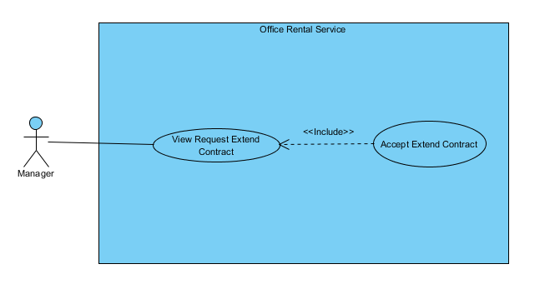

**Figure 9: <Manager> Accept extend contract use case diagram**

**Use Case Specification**

|  |  |  |  |  |
| --- | --- | --- | --- | --- |
| **USE CASE – ACCEPT EXTEND CONTRACT** | | | | |
| **Use-case No.** |  | **Use-case Version** | | 2.0 |
| **Use-case Name** | Accept Extend Contract | | | |
| **Author** | Trần Lê Tuấn | | | |
| **Date** | 25/05/2015 | **Priority** | Normal | |
| **Actor:**   * Manager   **Summary:**   * This use case allows manager to edit extend contract.   **Goal:**   * Manager can edit extend contract successful.   **Triggers:**   * Click “Yêu cầu của khách hàng” in menu. * Click “Xem chi tiết” icon in menu. * Click “Xác nhận” button.   **Preconditions:**   * User must login in system.   **Post Conditions:**   * **Success**: contract has been edited successfully. * **Fail:** Cannot edit contract.   **Main Success Scenario:**   |  |  |  | | --- | --- | --- | | Step | Actor Action | System Response | | 1 | Click “Yêu cầu khách hàng” on menu. |  | | 2 | Click “Gia hạn” on submenu. | Show page request detail  Display request details includes:   * Khách hàng: Label * Văn phòng: Label * Ngày bắt đầu: Label * Ngày kết thúc: Label * Giá: Label * Thời hạn thanh toán: Label * Xem chi tiết: Link | | 3 | Click “Xem chi tiết” link on screen. | Display request details includes:   * Khách hàng: Label * Văn phòng: Label * Ngày kết thúc: Textbox * Thời hạn thanh toán: Dropdown list * Giá: Textbox   “Xác nhận” : button  “Huỷ yêu cầu” : button  “Quay về” : button | | 4 | Click “Xác nhận” button on screen.  [Alternative 1] | Show successful message “Gia hạn thành công.” on screen.  [Exception 1] |   **Alternative Scenario:**   |  |  |  | | --- | --- | --- | | No. | Actor Action | System Response | | 1 | Click “Quay về” button. | Close request page and go to management page. |   **Exceptions:**   |  |  |  | | --- | --- | --- | | No. | Actor Action | System Response | | 1 | Cannot send request due to database connection | Show error message: “Không thể gửi yêu cầu, vui lòng thử lại sau.” |   **Relationships:** Contract  **Business Rules:**   * Accept extend request must exist in database system. * Extend contract will update after accept extend request. * Contract that accept extend request for must exist in database. | | | | |

##### < Manager/Staff> Create amenity

**Use Case Diagram**

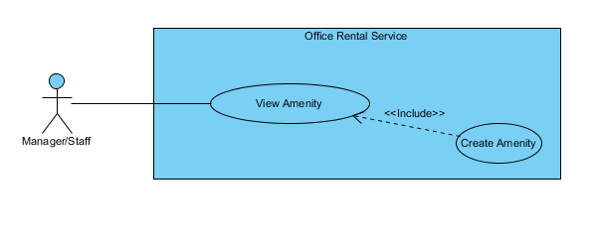

**Figure 10: <Manager/Staff> Create amenity use case diagram**

**Use Case Specification**

|  |  |  |  |  |
| --- | --- | --- | --- | --- |
| **USE CASE – CREATE AMENITY** | | | | |
| **Use-case No.** |  | **Use-case Version** | | 2.0 |
| **Use-case Name** | Create Amenity | | | |
| **Author** | Trần Lê Tuấn | | | |
| **Date** | 25/05/2015 | **Priority** | Normal | |
| **Actor:**   * Manager, Staff   **Summary:**   * This use case allows user to create amenity.   **Goal:**   * User can create amenity successful.   **Triggers:**   * Click “Quản lý tiện nghi” in menu. * Click “Thêm mới tiện nghi” in menu. * Fill amenity information. * Click “Tạo mới” button.   **Preconditions:**   * User must login in system.   **Post Conditions:**   * **Success**: Amenity has been created successfully. * **Fail:** Cannot create new amenity.   **Main Success Scenario:**   |  |  |  | | --- | --- | --- | | Step | Actor Action | System Response | | 1 | Click “Quản lý tiện nghi” on menu. | Show page detail  Display details includes:   * Thêm mới tiện nghi: Link * Tên tiện nghi: Label * Mô tả: Label * Trọng số: Label * Độ ưu tiên: Label   “Cập nhật” : button | | 2 | Click “Thêm mới tiện nghi” on menu. | Show page detail  Display details includes:   * Tên tiện nghi: Textbox * Mô tả: Textbox * Trọng số: Textbox * Độ ưu tiên: Textbox * Nhóm thiết bị: Dropdown List   “Huỷ” : button  “Tạo mới” : button | | 3 | Click “Tạo mới” button on screen.  [Alternative 1] | Show successful message “Thêm thiết bị thành công.” on screen.  [Exception 1] |   **Alternative Scenario:**   |  |  |  | | --- | --- | --- | | No. | Actor Action | System Response | | 1 | Click “Huỷ” button. | Close page and go to management page. |   **Exceptions:**   |  |  |  | | --- | --- | --- | | No. | Actor Action | System Response | | 1 | Cannot send request due to database connection | Show error message: “Không thể gửi yêu cầu, vui lòng thử lại sau.” |   **Relationships:** Amenity AmenityGroup  **Business Rules:**   * Name of create amenity must be different from existed name of amenity in system. * List amenity group must exist in database system. | | | | |

##### < Manager/Staff> Create amenity group

**Use Case Diagram**

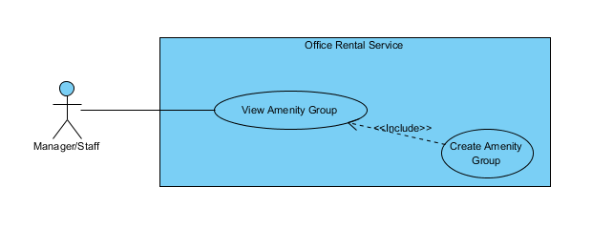

**Figure 11: <Manager/Staff> Create amenity group use case diagram**

**Use Case Specification**

|  |  |  |  |  |
| --- | --- | --- | --- | --- |
| **USE CASE – CREATE AMENITY GROUP** | | | | |
| **Use-case No.** |  | **Use-case Version** | | 2.0 |
| **Use-case Name** | Create Amenity Group | | | |
| **Author** | Trần Lê Tuấn | | | |
| **Date** | 25/05/2015 | **Priority** | Normal | |
| **Actor:**   * Manager, Staff   **Summary:**   * This use case allows user to create amenity group.   **Goal:**   * User can create amenity group successful.   **Triggers:**   * Click “Quản lý nhóm tiện nghi” in menu. * Click “Thêm mới nhóm tiện nghi” in menu. * Fill amenity group information. * Click “Tạo mới” button.   **Preconditions:**   * User must login in system.   **Post Conditions:**   * **Success**: Amenity has been created successfully. * **Fail:** Cannot create new amenity.   **Main Success Scenario:**   |  |  |  | | --- | --- | --- | | Step | Actor Action | System Response | | 1 | Click “Quản lý nhóm tiện nghi” on menu. |  | | 2 | Click “Thêm mới tiện nghi” on menu. | Show page detail  Display details includes:   * Tên tiện nghi: Textbox * Mô tả: Textbox   “Huỷ” : button  “Tạo mới” : button | | 3 | Click “Tạo mới” button on screen.  [Alternative 1] | Show successful message “Thêm nhóm thiết bị thành công.” on screen.  [Exception 1] |   **Alternative Scenario:**   |  |  |  | | --- | --- | --- | | No. | Actor Action | System Response | | 1 | Click “Huỷ” button. | Close page and go to management page. |   **Exceptions:**   |  |  |  | | --- | --- | --- | | No. | Actor Action | System Response | | 1 | Cannot send request due to database connection | Show error message: “Không thể gửi yêu cầu, vui lòng thử lại sau.” |   **Relationships:** Amenity AmenityGroup  **Business Rules:**   * Name of create amenity group must be different from existed name of amenity group in system. | | | | |

##### < Manager/Staff> Delete amenity

**Use Case Diagram**

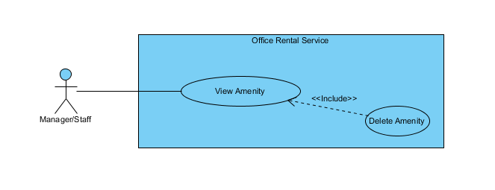

**Figure 12: <Manager/Staff> Delete amenity use case diagram**

**Use Case Specification**

|  |  |  |  |  |
| --- | --- | --- | --- | --- |
| **USE CASE – DELETE AMENITY** | | | | |
| **Use-case No.** |  | **Use-case Version** | | 2.0 |
| **Use-case Name** | Delete Amenity | | | |
| **Author** | Trần Lê Tuấn | | | |
| **Date** | 25/05/2015 | **Priority** | Normal | |
| **Actor:**   * Manager, Staff   **Summary:**   * This use case allows user to delete amenity.   **Goal:**   * User can delete amenity successful.   **Triggers:**   * Click “Quản lý tiện nghi” in menu. * Click “Xoá” button.   **Preconditions:**   * User must login in system.   **Post Conditions:**   * **Success**: Amenity has been created successfully. * **Fail:** Cannot create new amenity.   **Main Success Scenario:**   |  |  |  | | --- | --- | --- | | Step | Actor Action | System Response | | 1 | Click “Quản lý tiện nghi” on menu. | Show page detail  Display details includes:   * Thêm mới tiện nghi: Link * Tên tiện nghi: Label * Mô tả: Label * Trọng số: Label * Độ ưu tiên: Label   “Xoá” : button  “Cập nhật” : button | | 2 | Click “Xoá” button on screen. | Show successful message “Xoá thiết bị thành công.” on screen.  [Exception 1] |   **Alternative Scenario:**   |  |  |  | | --- | --- | --- | | No. | Actor Action | System Response | |  |  |  |   **Exceptions:**   |  |  |  | | --- | --- | --- | | No. | Actor Action | System Response | | 1 | Cannot send request due to database connection | Show error message: “Không thể gửi yêu cầu, vui lòng thử lại sau.” |   **Relationships:** Amenity AmenityGroup  **Business Rules:**   * Amenity that wants to be deleted must exist in database. * Amenity has to remove information in database. * Amenity group has to remove deleted amenity. * Amenity cannot display in amenity list. | | | | |

##### < Manager/Staff> Edit amenity

**Use Case Diagram**

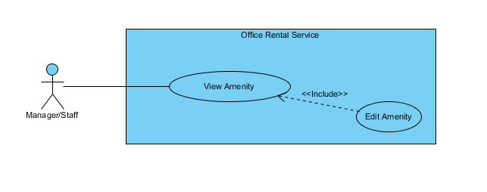

**Figure 13: <Manager/Staff> Edit amenity use case diagram**

**Use Case Specification**

|  |  |  |  |  |
| --- | --- | --- | --- | --- |
| **USE CASE – EDIT AMENITY** | | | | |
| **Use-case No.** |  | **Use-case Version** | | 2.0 |
| **Use-case Name** | Edit Amenity | | | |
| **Author** | Trần Lê Tuấn | | | |
| **Date** | 25/05/2015 | **Priority** | Normal | |
| **Actor:**   * Manager, Staff   **Summary:**   * This use case allows user to edit amenity.   **Goal:**   * User can edit amenity successful.   **Triggers:**   * Click “Quản lý tiện nghi” in menu. * Click “Cập nhật” in menu. * Fill amenity group information. * Click “Cập nhật” button.   **Preconditions:**   * User must login in system.   **Post Conditions:**   * **Success**: Amenity has been created successfully. * **Fail:** Cannot create new amenity.   **Main Success Scenario:**   |  |  |  | | --- | --- | --- | | Step | Actor Action | System Response | | 1 | Click “Quản lý tiện nghi” on menu. | Show page detail  Display details includes:   * Thêm mới tiện nghi: Link * Tên tiện nghi: Label * Mô tả: Label * Trọng số: Label * Độ ưu tiên: Label   “Cập nhật” : button | | 2 | Click “Thêm mới tiện nghi” on menu. | Show page request detail  Display request details includes:   * Tên tiện nghi: Label * Mô tả: Textbox * Trọng số: Textbox * Độ ưu tiên: Textbox   “Huỷ” : button  “Cập nhật” : button | | 3 | Click “Cập nhật” button on screen.  [Alternative 1] | Show successful message “Cập nhật thiết bị thành công.” on screen.  [Exception 1] |   **Alternative Scenario:**   |  |  |  | | --- | --- | --- | | No. | Actor Action | System Response | | 1 | Click “Huỷ” button. | Close page and go to management page. |   **Exceptions:**   |  |  |  | | --- | --- | --- | | No. | Actor Action | System Response | | 1 | Cannot send request due to database connection | Show error message: “Không thể gửi yêu cầu, vui lòng thử lại sau.” |   **Relationships:** Amenity AmenityGroup  **Business Rules:**   * Amenity information must exist in database system. * Amenity group information must exist in database system. * Amenity name cannot change. | | | | |

##### < Manager/Staff> Edit amenity group

**Use Case Diagram**

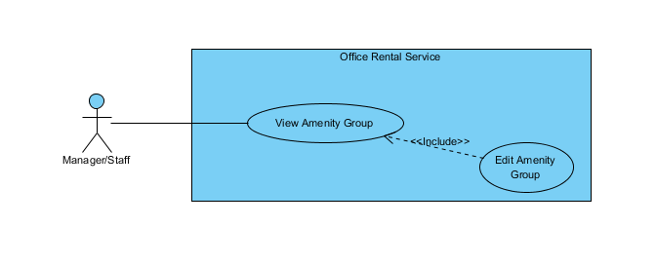

**Figure 14: <Manager/Staff> Edit amenity group use case diagram**

**Use Case Specification**

|  |  |  |  |  |
| --- | --- | --- | --- | --- |
| **USE CASE – EDIT AMENITY GROUP** | | | | |
| **Use-case No.** |  | **Use-case Version** | | 2.0 |
| **Use-case Name** | Edit Amenity Group | | | |
| **Author** | Trần Lê Tuấn | | | |
| **Date** | 25/05/2015 | **Priority** | Normal | |
| **Actor:**   * Manager, Staff   **Summary:**   * This use case allows user to create amenity group.   **Goal:**   * User can create amenity group successful.   **Triggers:**   * Click “Quản lý nhóm tiện nghi” in menu. * Click “Cập nhật” in menu. * Fill amenity group information. * Click “Cập nhật” button.   **Preconditions:**   * User must login in system.   **Post Conditions:**   * **Success**: Amenity has been created successfully. * **Fail:** Cannot create new amenity.   **Main Success Scenario:**   |  |  |  | | --- | --- | --- | | Step | Actor Action | System Response | | 1 | Click “Quản lý nhóm tiện nghi” on menu. | Show page detail  Display details includes:   * Thêm mới nhóm tiện nghi: Link * Tên nhóm: Label * Mô tả: Label   “Xoá” : button  “Cập nhật” : button  [Exception 1] | | 2 | Click “Cập nhật” on menu. | Show page request detail  Display request details includes:   * Tên tiện nghi: Label * Mô tả: Textbox   “Huỷ” : button  “Cập nhật” : button | | 3 | Click “Cập nhật” button on screen.  [Alternative 1] | Show successful message “Cập nhật nhóm thiết bị thành công.” on screen.  [Exception 1] |   **Alternative Scenario:**   |  |  |  | | --- | --- | --- | | No. | Actor Action | System Response | | 1 | Click “Huỷ” button. | Close page and go to management page. |   **Exceptions:**   |  |  |  | | --- | --- | --- | | No. | Actor Action | System Response | | 1 | Cannot send request due to database connection | Show error message: “Không thể gửi yêu cầu, vui lòng thử lại sau.” |   **Relationships:** Amenity AmenityGroup  **Business Rules:**   * Amenity information must exist in database system. * Amenity group information must exist in database system. * Amenity group name cannot change. | | | | |

##### < Manager/Staff> View amenity group list

**Use Case Diagram**

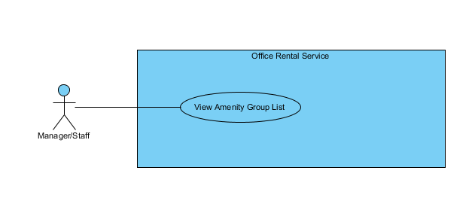

**Figure 15: <Manager/Staff> View amenity group list use case diagram**

**Use Case Specification**

|  |  |  |  |  |
| --- | --- | --- | --- | --- |
| **USE CASE – VIEW AMENITY GROUP LIST** | | | | |
| **Use-case No.** |  | **Use-case Version** | | 2.0 |
| **Use-case Name** | View Amenity Group List | | | |
| **Author** | Trần Lê Tuấn | | | |
| **Date** | 25/05/2015 | **Priority** | Normal | |
| **Actor:**   * Manager, Staff   **Summary:**   * This use case allows user to view amenity group list.   **Goal:**   * User can view amenity group list successful.   **Triggers:**   * Click “Quản lý nhóm tiện nghi” in menu.   **Preconditions:**   * User must login in system.   **Post Conditions:**   * **Success**: Amenity list has been viewed successfully. * **Fail:** Cannot view amenity list.   **Main Success Scenario:**   |  |  |  | | --- | --- | --- | | Step | Actor Action | System Response | | 1 | Click “Quản lý nhóm tiện nghi” on menu. | Show page detail  Display details includes:   * Tên nhóm: Label * Mô tả: Label   “Xoá” : button  “Cập nhật” : button  [Exception 1] | |  |  |  |   **Alternative Scenario:**   |  |  |  | | --- | --- | --- | | No. | Actor Action | System Response | |  |  |  |   **Exceptions:**   |  |  |  | | --- | --- | --- | | No. | Actor Action | System Response | | 1 | Cannot send request due to database connection | Show error message: “Không thể gửi yêu cầu, vui lòng thử lại sau.” |   **Relationships:** Amenity AmenityGroup  **Business Rules:**   * Amenity group information must exist in database system. * If amenity group has been deleted, manager can’t view it. | | | | |

##### < Manager/Staff> View amenity group list

**Use Case Diagram**

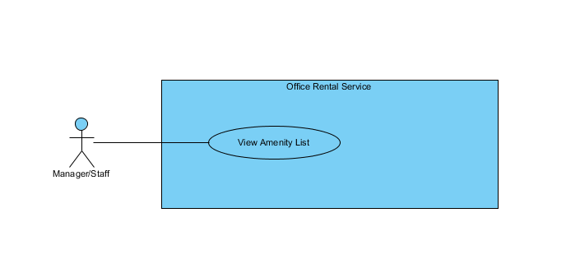

**Figure 16: <Manager/Staff> View amenity list use case diagram**

**Use Case Specification**

|  |  |  |  |  |
| --- | --- | --- | --- | --- |
| **USE CASE – VIEW AMENITY LIST** | | | | |
| **Use-case No.** |  | **Use-case Version** | | 2.0 |
| **Use-case Name** | View Amenity List | | | |
| **Author** | Trần Lê Tuấn | | | |
| **Date** | 25/05/2015 | **Priority** | Normal | |
| **Actor:**   * Manager, Staff   **Summary:**   * This use case allows user to view amenity list.   **Goal:**   * User can view amenity list successful.   **Triggers:**   * Click “Quản lí tiện nghi” in menu.   **Preconditions:**   * User must login in system.   **Post Conditions:**   * **Success**: Amenity list has been viewed successfully. * **Fail:** Cannot view amenity list.   **Main Success Scenario:**   |  |  |  | | --- | --- | --- | | Step | Actor Action | System Response | | 1 | Click “Quản lý tiện nghi” on menu. | Show page detail  Display details includes:   * Tên tiện nghi: Label * Mô tả: Label * Trọng số: Label * Độ ưu tiên: Label   “Cập nhật” : button  [Exception 1] |   **Alternative Scenario:**   |  |  |  | | --- | --- | --- | | No. | Actor Action | System Response | |  |  |  |   **Exceptions:**   |  |  |  | | --- | --- | --- | | No. | Actor Action | System Response | | 1 | Cannot send request due to database connection | Show error message: “Không thể gửi yêu cầu, vui lòng thử lại sau.” |   **Relationships:** Amenity AmenityGroup  **Business Rules:**   * Amenity information must exist in database system. * Amenity group information must exist in database system. * If amenity has been deleted, manager can’t view it. | | | | |

|  |  |  |  |  |
| --- | --- | --- | --- | --- |
| **USE CASE – VIEW CONTRACT LIST** | | | | |
| **Use-case No.** |  | **Use-case Version** | | 2.0 |
| **Use-case Name** | View Contract List | | | |
| **Author** | Trần Lê Tuấn | | | |
| **Date** | 25/05/2015 | **Priority** | Normal | |
| **Actor:**   * Manager   **Summary:**   * This use case allows user to view contract list.   **Goal:**   * User can view contract list successful.   **Triggers:**   * Click “Hợp đồng” in menu.   **Preconditions:**   * User must login in system.   **Post Conditions:**   * **Success**: Contract list has been viewed successfully. * **Fail:** Cannot viewed contract list.   **Main Success Scenario:**   |  |  |  | | --- | --- | --- | | Step | Actor Action | System Response | | 1 | Click “Hợp đồng” on menu. | Show page detail  Display details includes:   * Khách hàng: Label * Văn phòng: Label * Ngày bắt đầu: Label * Ngày kết thúc: Label * Giá: Label * Thời hạn thanh toán: Label   “Cập nhật” : button  [Exception 1] |   **Alternative Scenario: N/A**  **Exceptions:**   |  |  |  | | --- | --- | --- | | No. | Actor Action | System Response | | 1 | Cannot send request due to database connection | Show error message: “Không thể gửi yêu cầu, vui lòng thử lại sau.” |   **Relationships:** Contract  **Business Rules:**   * Contract information must exist in database system. * If contract expire, manager can’t view it. | | | | |

##### < Manager > View request extend contract

**Use Case Diagram**

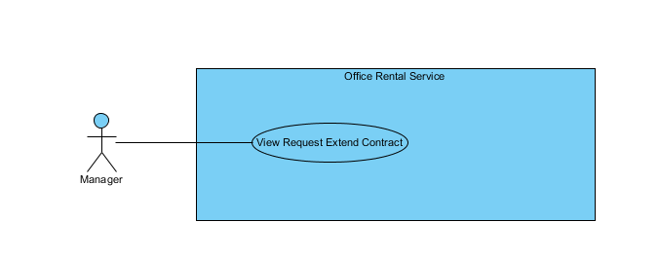

**Figure 17: <Manager > View request extend contract use case diagram**

**Use Case Specification**

|  |  |  |  |  |
| --- | --- | --- | --- | --- |
| **USE CASE – VIEW REQUEST EXTEND CONTRACT** | | | | |
| **Use-case No.** |  | **Use-case Version** | | 2.0 |
| **Use-case Name** | View Request Extend Contract | | | |
| **Author** | Trần Lê Tuấn | | | |
| **Date** | 25/05/2015 | **Priority** | Normal | |
| **Actor:**   * Manager   **Summary:**   * This use case allows user to view request extend contract list.   **Goal:**   * User can view request extend contract list successful.   **Triggers:**   * Click “Yêu cầu khách hàng” in menu. * Click “Gia hạn” in submenu   **Preconditions:**   * User must login in system.   **Post Conditions:**   * **Success**: Request extend contract list has been viewed successfully. * **Fail:** Cannot view request extend contract list.   **Main Success Scenario:**   |  |  |  | | --- | --- | --- | | Step | Actor Action | System Response | | 1 | Click “Hợp đồng” on menu. |  | | 2 | Click “Gia hạn” in submenu | Show page detail  Display details includes:   * Khách hàng: Label * Văn phòng: Label * Ngày bắt đầu: Label * Ngày kết thúc: Label * Giá: Label * Thời hạn thanh toán * “Xem chi tiết”: Link   [Exception 1] |   **Alternative Scenario: N/A**  **Exceptions:**   |  |  |  | | --- | --- | --- | | No. | Actor Action | System Response | | 1 | Cannot send request due to database connection | Show error message: “Không thể gửi yêu cầu, vui lòng thử lại sau.” |   **Relationships:** Contract  **Business Rules:**   * Request information must exist in database system. | | | | |

##### < Staff > View assigned repair request

**Use Case Diagram**

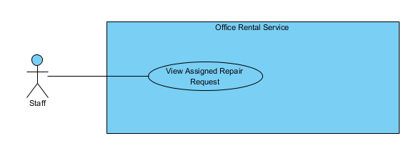

**Figure 18: <Staff > View assigned repair request use case diagram**

**Use Case Specification**

|  |  |  |  |  |
| --- | --- | --- | --- | --- |
| **USE CASE – VIEW ASSIGNED REPAIR REQUEST** | | | | |
| **Use-case No.** |  | **Use-case Version** | | 2.0 |
| **Use-case Name** | View Assigned Repair Request | | | |
| **Author** | Trần Lê Tuấn | | | |
| **Date** | 25/05/2015 | **Priority** | Normal | |
| **Actor:**   * Staff   **Summary:**   * This use case allows user to view assigned repair request.   **Goal:**   * User can view assigned repair request successful.   **Triggers:**   * Click “Sửa chữa” in menu.   **Preconditions:**   * User must login in system.   **Post Conditions:**   * **Success**: Assigned repair request has been viewed successfully. * **Fail:** Cannot view Assigned repair request.   **Main Success Scenario:**   |  |  |  | | --- | --- | --- | | Step | Actor Action | System Response | | 1 | Click “Sửa chữa” on menu. | Show page detail  Display details includes:   * Tên văn phòng: Label * Khách hàng: Label * Ngày sửa chữa: Label * Mô tả: Label * “Xem chi tiết”: Link   [Exception 1] |   **Alternative Scenario:**   |  |  |  | | --- | --- | --- | | No. | Actor Action | System Response | |  |  |  |   **Exceptions:**   |  |  |  | | --- | --- | --- | | No. | Actor Action | System Response | | 1 | Cannot send request due to database connection | Show error message: “Không thể gửi yêu cầu, vui lòng thử lại sau.” |   **Relationships:** Repair  **Business Rules:**   * Request information must exist in database system. | | | | |

##### < Manager > View request return contract

**Use Case Diagram**

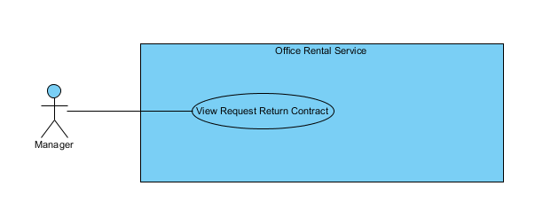

**Figure 19: <Manager > View request return contract use case diagram**

**Use Case Specification**

|  |  |  |  |  |
| --- | --- | --- | --- | --- |
| **USE CASE – VIEW REQUEST RETURN CONTRACT** | | | | |
| **Use-case No.** |  | **Use-case Version** | | 2.0 |
| **Use-case Name** | View Request Return Contract | | | |
| **Author** | Trần Lê Tuấn | | | |
| **Date** | 25/05/2015 | **Priority** | Normal | |
| **Actor:**   * Manager   **Summary:**   * This use case allows user to view request return contract list.   **Goal:**   * User can view request return contract list successful.   **Triggers:**   * Click “Yêu cầu khách hàng” in menu. * Click “Huỷ trước hạn” in submenu   **Preconditions:**   * User must login in system.   **Post Conditions:**   * **Success**: Return request contract list has been viewed successfully. * **Fail:** Cannot view return request contract list.   **Main Success Scenario:**   |  |  |  | | --- | --- | --- | | Step | Actor Action | System Response | | 1 | Click “Hợp đồng” on menu. |  | | 2 | Click “Huỷ trước hạn” in submenu | Show page detail  Display details includes:   * Khách hàng: Label * Văn phòng: Label * Ngày bắt đầu: Label * Ngày kết thúc: Label * Giá: Label * Thời hạn thanh toán: Label * “Xem chi tiet”: Link   [Exception 1] |   **Alternative Scenario: N/A**  **Exceptions:**   |  |  |  | | --- | --- | --- | | No. | Actor Action | System Response | | 1 | Cannot send request due to database connection | Show error message: “Không thể gửi yêu cầu, vui lòng thử lại sau.” |   **Relationships:** Contract  **Business Rules:**   * Request information must exist in database system. | | | | |

##### < Staff > Change repair status

##### Use Case Diagram

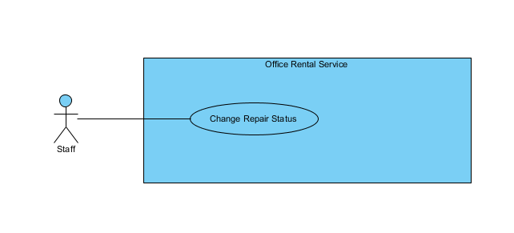

**Figure 20: <Staff > Change repair status use case diagram**

**Use Case Specification**

|  |  |  |  |  |
| --- | --- | --- | --- | --- |
| **USE CASE – CHANGE REPAIR STATUS** | | | | |
| **Use-case No.** |  | **Use-case Version** | | 2.0 |
| **Use-case Name** | Change Repair Status | | | |
| **Author** | Trần Lê Tuấn | | | |
| **Date** | 25/05/2015 | **Priority** | Normal | |
| **Actor:**   * Staff   **Summary:**   * This use case allows user to change repair status.   **Goal:**   * User can change repair status successful.   **Triggers:**   * Click “Sửa chữa” in menu. * Click “Xem chi tiết” in submenu   **Preconditions:**   * User must login in system.   **Post Conditions:**   * **Success**: Repair status has been changed successfully. * **Fail:** Cannot change repair status.   **Main Success Scenario:**   |  |  |  | | --- | --- | --- | | Step | Actor Action | System Response | | 1 | Click “Sửa chữa” on menu. | Show page detail  Display details includes:   * Tên văn phòng: Label * Khách hàng: Label * Ngày sửa chữa: Label * Mô tả: Label * “Xem chi tiết”: Link | | 2 | Click “Xem chi tiết” in submenu | Show page detail  Display details includes:   * Tên văn phòng: Label * Khách hàng: Label * Ngày tạo: Label * Mô tả: Label * Ngày sửa chữa: Label * Tình trạng: Label * “Đồng ý sửa” : Button * “Không đồng ý sửa” : Button | | 3 | Click “Đồng ý sửa” button  [Alternative 1] | Show successful message “Chấp nhận yêu cầu thành công.” on screen.  [Exception 1] |   **Alternative Scenario:**   |  |  |  | | --- | --- | --- | | No. | Actor Action | System Response | | 1 | Click “Không đồng ý sửa” button | Show successful message “Chập nhận yêu cầu thành công.” on screen.  [Exception 1] |   **Exceptions:**   |  |  |  | | --- | --- | --- | | No. | Actor Action | System Response | | 1 | Cannot send request due to database connection | Show error message: “Không thể gửi yêu cầu, vui lòng thử lại sau.” |   **Relationships:** Repair  **Business Rules:**   * Staff cannot change status request of other staff. * Request information must exist in database system. * Done request cannot change status | | | | |

##### < Staff > View account list

##### Use Case Diagram

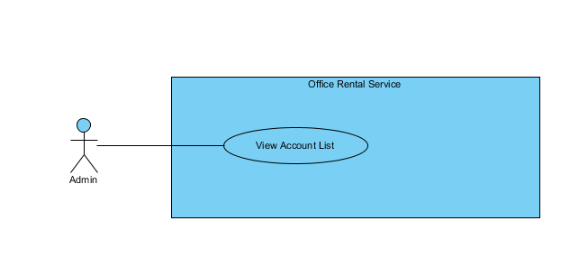

**Figure 21: <Staff > View account list use case diagram**

**Use Case Specification**

|  |  |  |  |  |
| --- | --- | --- | --- | --- |
| **USE CASE – VIEW ACCOUNT LIST** | | | | |
| **Use-case No.** |  | **Use-case Version** | | 2.0 |
| **Use-case Name** | View Account List | | | |
| **Author** | Trần Lê Tuấn | | | |
| **Date** | 25/05/2015 | **Priority** | Normal | |
| **Actor:**   * Admin   **Summary:**   * This use case allows admin to view account list.   **Goal:**   * Admin can view account list successful.   **Triggers:**   * Click “Người dùng” in menu.   **Preconditions:**   * User must login in system.   **Post Conditions:**   * **Success**: create view account list successfully. * **Fail:** Cannot view account list   **Main Success Scenario:**   |  |  |  | | --- | --- | --- | | Step | Actor Action | System Response | | 1 | Click “Người dùng” on menu. | Show page account management  Display account details includes:   * Thêm mới tài khoản: Link * Tên đăng nhập: Label * Email: Password * Chức vụ: Dropdown list * Tình trạng: Label * Tác vụ:   + “Xoá”: Button  +”Sửa”: Button  [Exception 1] | |  |  |  |   **Alternative Scenario:**   |  |  |  | | --- | --- | --- | | No. | Actor Action | System Response |   **Exceptions:**   |  |  |  | | --- | --- | --- | | No. | Actor Action | System Response | | 1 | Cannot send request due to database connection | Show error message: “Không thể gửi yêu cầu, vui lòng thử lại sau.” |   **Relationships:** Role Account  **Business Rules:**   * Account information must exist in database system. * Deleted account cannot view. | | | | |